**Detect personally identifiable information (PII) in text**

PII detection is one of the features offered by [Azure AI Language](https://learn.microsoft.com/en-us/azure/ai-services/language-service/overview), a collection of machine learning and AI algorithms in the cloud for developing intelligent applications that involve written language. The PII detection feature can **identify, categorize, and redact** sensitive information in unstructured text. For example: phone numbers, email addresses, and forms of identification. Azure AI Language supports general text PII redaction, as well as [Conversational PII](https://learn.microsoft.com/en-us/azure/ai-services/language-service/personally-identifiable-information/how-to-call-for-conversations), a specialized model for handling speech transcriptions and the more informal, conversational tone of meeting and call transcripts. The service also supports [Native Document PII redaction](https://learn.microsoft.com/en-us/azure/ai-services/language-service/personally-identifiable-information/overview#native-document-support), where the input and output are structured document files.

**Typical workflow**

To use this feature, you submit data for analysis and handle the API output in your application. Analysis is performed as-is, with no added customization to the model used on your data.

1. Create an Azure AI Language resource, which grants you access to the features offered by Azure AI Language. It generates a password (called a key) and an endpoint URL that you use to authenticate API requests.
2. Create a request using either the REST API or the client library for C#, Java, JavaScript, and Python. You can also send asynchronous calls with a batch request to combine API requests for multiple features into a single call.
3. Send the request containing your text data. Your key and endpoint are used for authentication.
4. Stream or store the response locally.

**Native document support**

A native document refers to the file format used to create the original document such as Microsoft Word (docx) or a portable document file (pdf). Native document support eliminates the need for text preprocessing prior to using Azure AI Language resource capabilities. Currently, native document support is available for the [**PiiEntityRecognition**](https://learn.microsoft.com/en-us/azure/ai-services/language-service/personally-identifiable-information/concepts/entity-categories) capability.

Currently **PII** supports the following native document formats:

**Get started with PII detection**

To use PII detection, you submit text for analysis and handle the API output in your application. Analysis is performed as-is, with no customization to the model used on your data. There are two ways to use PII detection:



**using the client library and REST API**

**Create an Azure resource**

To use the code sample below, you'll need to deploy an Azure resource. This resource will contain a key and endpoint you'll use to authenticate the API calls you send to the Language service.

1. Use the following link to [create a language resource](https://portal.azure.com/#create/Microsoft.CognitiveServicesTextAnalytics) using the Azure portal. You will need to sign in using your Azure subscription.
2. On the **Select additional features** screen that appears, select **Continue to create your resource**.

[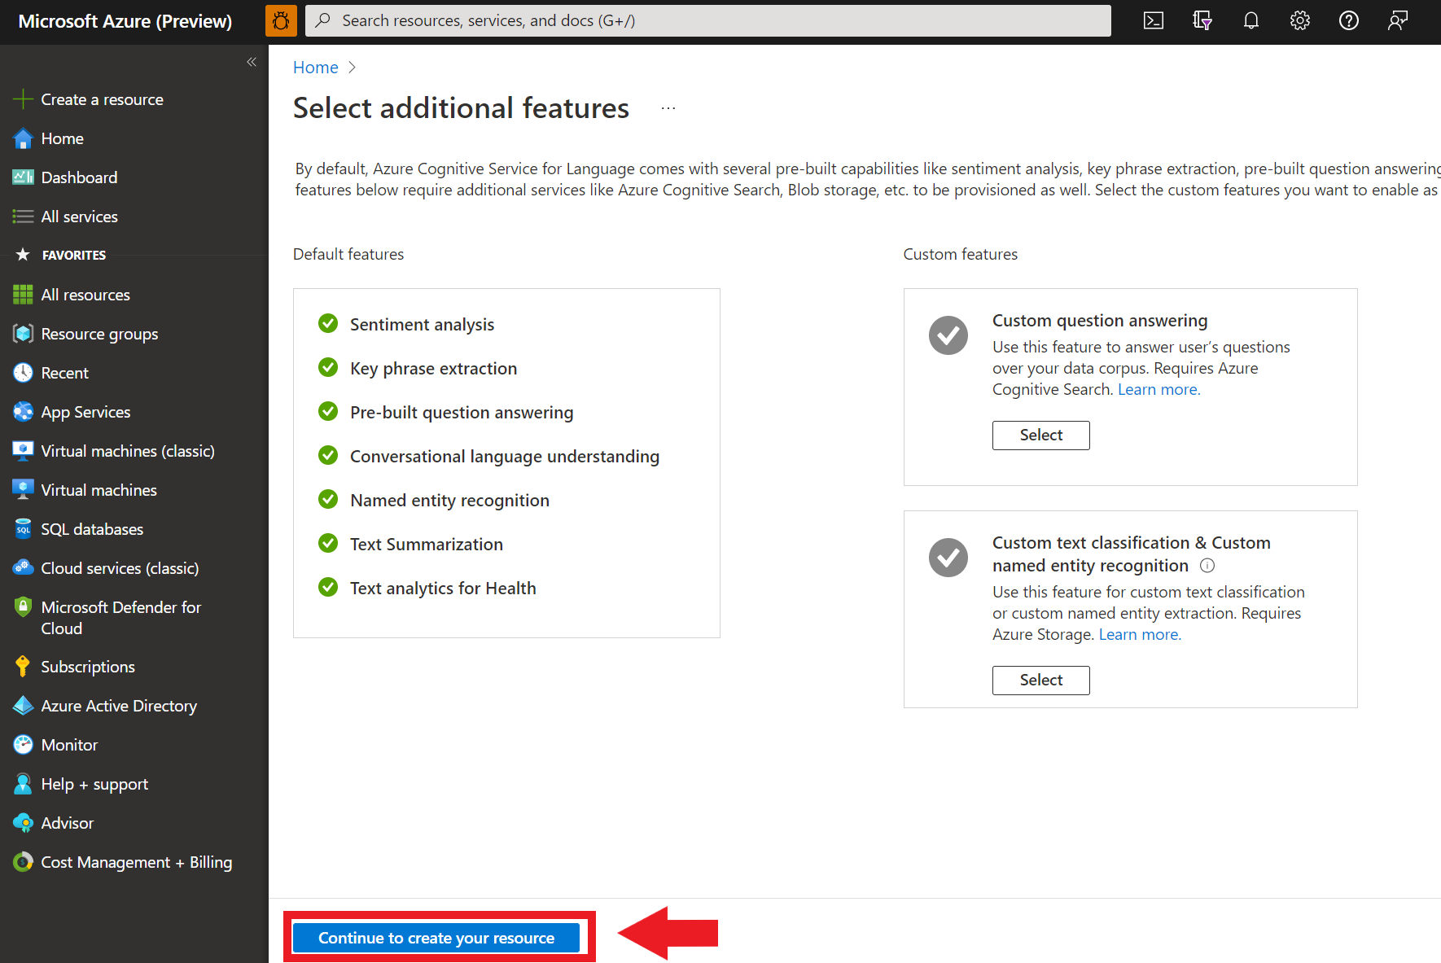](https://learn.microsoft.com/en-us/azure/ai-services/language-service/media/portal-resource-additional-features.png#lightbox)

1. In the **Create language** screen, provide the following information:

[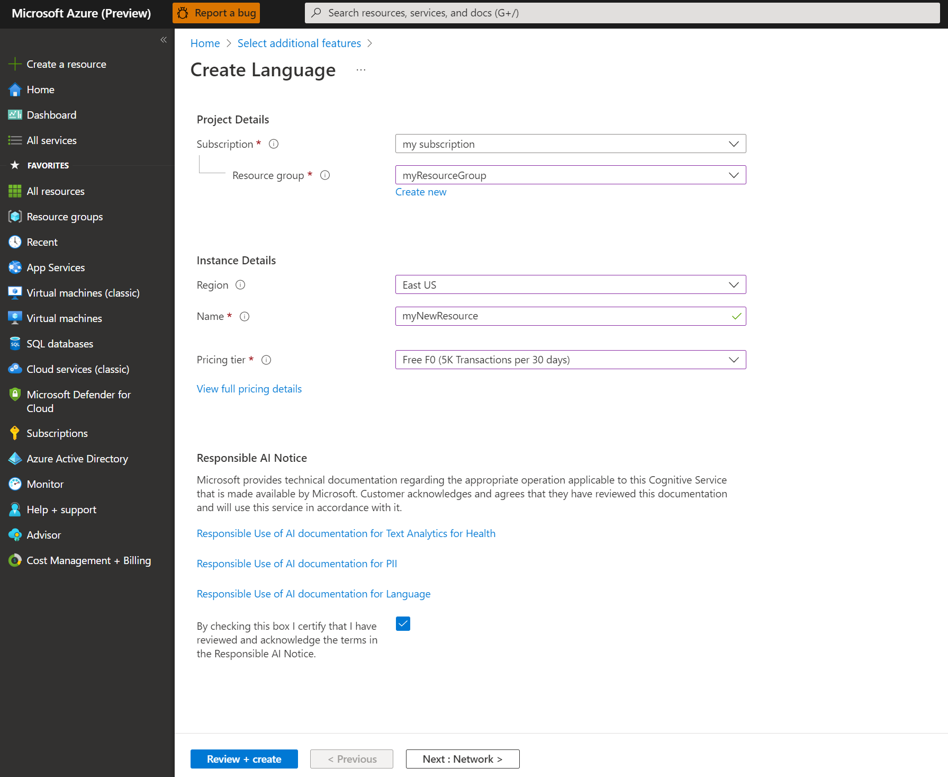](https://learn.microsoft.com/en-us/azure/ai-services/language-service/media/portal-resource-creation-details.png#lightbox)

1. Make sure the **Responsible AI Notice** checkbox is checked.
2. Select **Review + Create** at the bottom of the page.
3. In the screen that appears, make sure the validation has passed, and that you entered your information correctly. Then select **Create**.

**Get your key and endpoint**

Next you will need the key and endpoint from the resource to connect your application to the API. You'll paste your key and endpoint into the code later in the quickstart.

1. After the Language resource deploys successfully, click the **Go to Resource** button under **Next Steps**.

[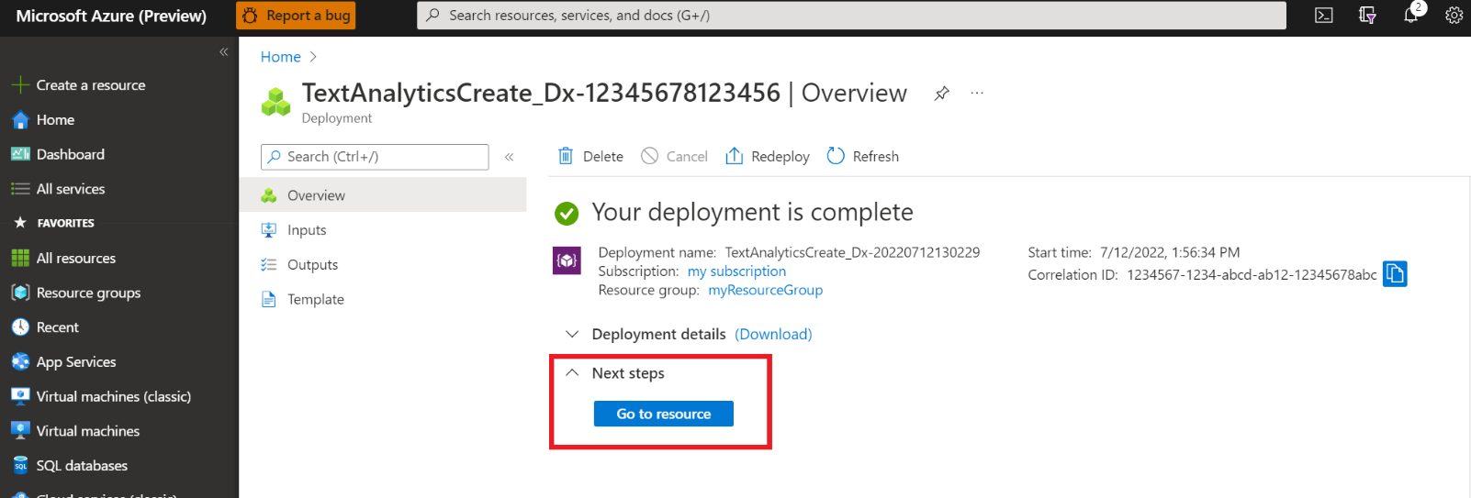](https://learn.microsoft.com/en-us/azure/ai-services/language-service/media/portal-resource-next-steps.png#lightbox)

1. On the screen for your resource, select **Keys and endpoint** on the left navigation menu. You will use one of your keys and your endpoint in the steps below.

[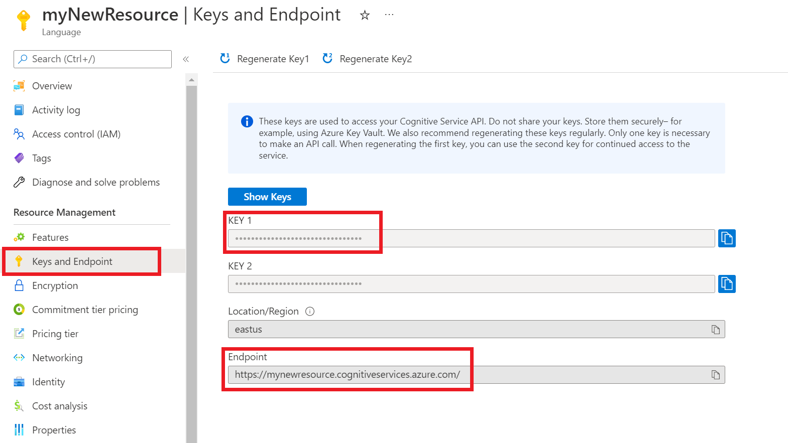](https://learn.microsoft.com/en-us/azure/ai-services/language-service/media/azure-portal-resource-credentials.png#lightbox)

**Create a new .NET Core application**

Using the Visual Studio IDE, create a new .NET Core console app. This creates a "Hello World" project with a single C# source file: *program.cs*.

Install the client library by right-clicking on the solution in the Solution Explorer and selecting Manage NuGet Packages. In the package manager that opens select Browse and search for Azure.AI.TextAnalytics. Select version 5.2.0, and then Install. You can also use the [Package Manager Console](https://learn.microsoft.com/en-us/nuget/consume-packages/install-use-packages-powershell#find-and-install-a-package).

**Code example**

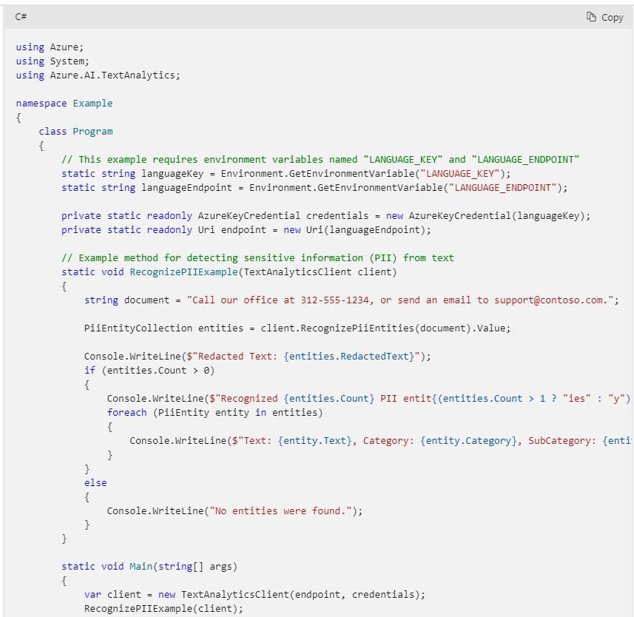

**Output**

**Use Language Studio with your own text**

